**Batch: C1 Roll No.: 16010122236**

**Experiment / assignment / tutorial No. 10**

|  |
| --- |
| **TITLE:** Study of Karnaugh Map concepts through Virtual lab |

**AIM:** Understanding Virtual Lab concepts

**_______________________________________________________________**

**Expected OUTCOME of Experiment:**

**__________________________________________________________________**

**Books/ Journals/ Websites referred:**

<http://vlabs.iitb.ac.in/vlab/labscse.html>

[http://vlabs.iitb.ac.in/vlab/#](http://vlabs.iitb.ac.in/vlab/)

<http://www.vlab.co.in/>

**_____________________________________________________________________**

**Pre Lab/ Prior Concepts:**

The main aim of this experiment is to provide remote-access to Labs in various disciplines of Science and Engineering. These Virtual Labs would cater to students at the undergraduate level, post graduate level as well as to research scholars. Also, to enthuse students to conduct experiments by arousing their curiosity. This would help them in learning basic and advanced concepts through remote experimentation. It also provides a complete Learning Management System around the Virtual Labs where the students can avail the various tools for learning, including additional web-resources, video-lectures, animated demonstrations and self-evaluation. We can share costly equipment and resources, which are otherwise available to limited number of users due to constraints on time and geographical distances

**Salient Features:**

. 1. Virtual Labs will provide to the students the result of an experiment by one of the following methods (or possibly a combination)

* Modeling the physical phenomenon by a set of equations and carrying out simulations to yield the result of the particular experiment. This can, at-the-best, provide an approximate version of the ‘real-world’ experiment.
* Providing measured data for virtual lab experiments corresponding to the data previously obtained by measurements on an actual system.
* Remotely triggering an experiment in an actual lab and providing the student the result of the experiment through the computer interface. This would entail carrying out the actual lab experiment remotely.

2. Virtual Labs will be made more effective and realistic by providing additional inputs to the students like accompanying audio and video streaming of an actual lab experiment and equipment.

**Observations**

**Title of Study Experiment: Karnaugh Map**

**Brief description of experiment under study :**

A ***Karnaugh Map*** provides a pictorial method of grouping together expressions with common factors and therefore eliminating unwanted variables. The Karnaugh map can also be described as a special arrangement of a truth table.

A minimal sum-of-product design can be created as follows:

* Create the K-map, entering a 1 or 0 in each square according to the desired logic function
* Beginning with large rectangles and going to small rectangles, add rectangles until all minterms are 'covered' (all '1's are included).
* Generate the algebraic terms corresponding to the rectangles

**Learning’s recorded:**

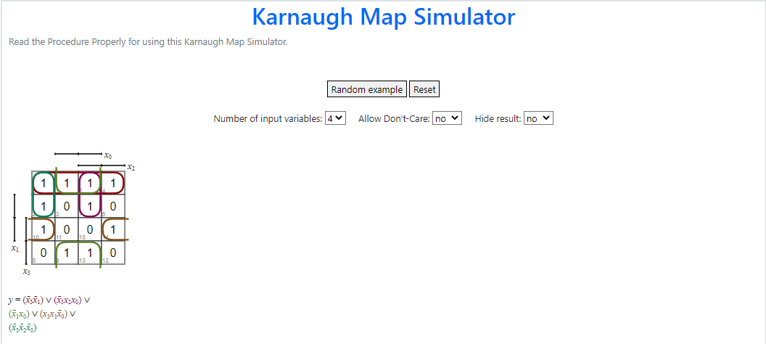

4 variable K-Map

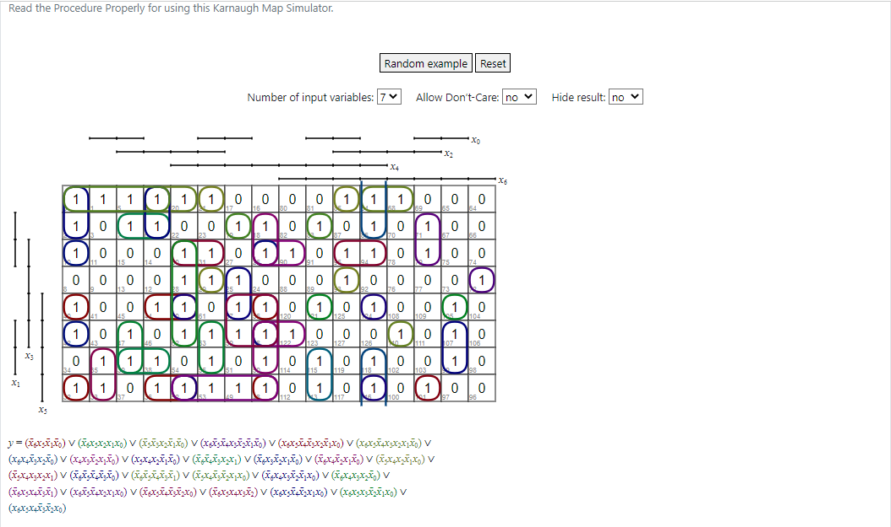

7 variable K-Map

**Knowledge gained / Inference Obtained :**

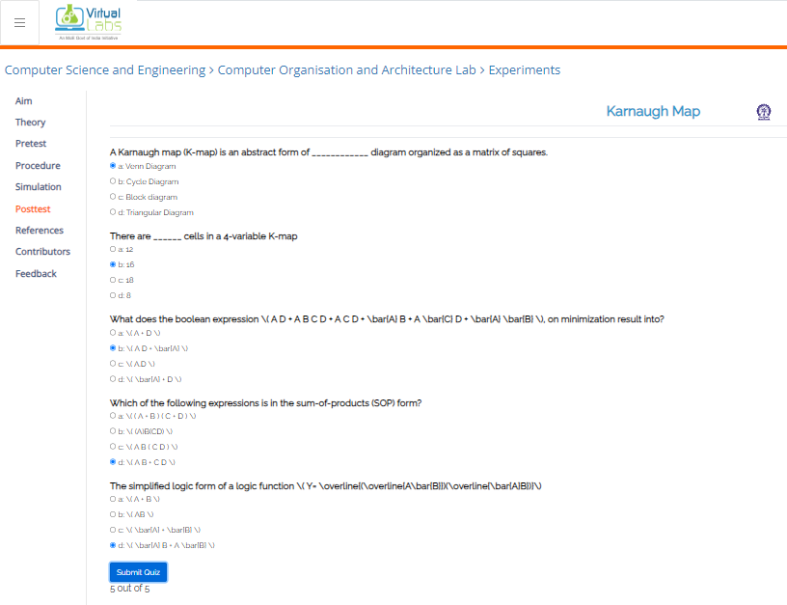

**Post Lab Descriptive Questions**

**Q1) What are the applications of the virtual lab case study / tool reviewed by you?**

1. Education: It helps students learn Karnaugh Maps and simplifying Boolean expressions, essential in digital logic courses.

2. Digital Circuit Design: Engineers and professionals use it to optimize circuits, reduce component count, and troubleshoot digital systems.

3. Research and Experimentation: Valuable for experimentation and research in digital system optimization.

4. Design Validation: Useful for validating and optimizing logic circuits before implementation.

5. Digital Logic Competitions: Helpful for practicing Karnaugh Map skills in preparation for competitions and exams.

**Conclusion:**

In conclusion, the study of Karnaugh Map concepts through a Virtual Lab offers an engaging and effective way to grasp fundamental principles of digital logic and circuit design. This tool empowers students and professionals to learn, practice, and apply Karnaugh Maps in simplifying Boolean expressions, optimizing digital circuits, and troubleshooting systems. It not only enhances educational experiences but also supports research, design validation, and preparation for digital logic competitions. Through the Virtual Lab, individuals can bridge the gap between theory and hands-on application, gaining valuable insights into the world of digital logic.